Protocol for updating the carbon index website

<https://emissionsindex.org/>

last updated April 23, 2020

Note: there are 5 videos that illustrate parts of this protocol. Ask Costa for them.

**Check for Data**

1. We will release each quarter on the following schedule as long as the underlying data have been published:

|  |  |  |  |  |
| --- | --- | --- | --- | --- |
| Quarter | Months Included | EIA 923/923m Released | EPA CEMS Released | Carbon Index Released |
| Q1 | 1,2,3 | Jun | May | Jul |
| Q2 | 4,5,6 | Sep | Aug | Oct |
| Q3 | 7,8,9 | Dec | Nov | Jan |
| Q4 | 10,11,12 | Mar | Feb | Apr |

1. Before continuing, make sure the underlying data have been published and that they include the months in the “Months Included Column” above.
   1. EIA 923: <https://www.eia.gov/electricity/data/eia923/>
      1. See the list of .zip files on the right of the webpage
      2. The highest .zip file will be the most recent
      3. If the year is incomplete, the ‘year’ description end by stating the last month of data contained in that dataset
   2. EPA CEMS: <ftp://newftp.epa.gov/DmDnLoad/emissions/hourly/monthly/>
      1. Click the relevant year
      2. The last two digits of each file show the .zip file’s month
2. If the data include the necessary months, continue.

**Setup Git and Download the Carbon Index Project**

Git is a version control software. It will track changes that you make to files, let you download changes that other users make to files, and help you upload your changes to the master set of files that is hosted online.

If you want a better understanding of how git works, here is a great [resource](https://github.com/MichaelDesantis/No-Nonsense-Github-Project). It contains a 1-hour set of videos. It also contains some instructions with links to helpful git debugging files. I’ll do my best to walk you through all the necessary information here.

1. Install [Git](https://git-scm.com/book/en/v2/Getting-Started-Installing-Git)
2. Set up your user name and email
   1. Open command prompt
   2. Type git config --global user.name <your name>
      1. Where <your name> is whatever username you want associated with your work
   3. Type git config --global user.email <your email>
      1. Where <your email> is the email that you will use to set up your github account in the next step.
   4. You can check your name and email by entering git config --list
3. Setup a [github](https://github.com/) account
4. Cache your github password in Git
   1. This allows you to freely upload/download between your local computer and your github account without having to put in your username/password each time.
   2. Check the following for details:
      1. <https://help.github.com/en/github/using-git/caching-your-github-password-in-git>
      2. the protocol is slightly different depending on your operating system
5. Fork the EmissionsIndex/carbon-index repository
   1. Log in to your github account
   2. Navigate to <https://github.com/EmissionsIndex/carbon-index>
   3. On the far right, click the “Fork” button
      1. 
   4. This will initiate a fork to your github account. A fork is basically a copy of the original. The fork will allow you to download and upload changes to the code without needing the EmissionIndex password. Instead, you will download/upload changes to your own github account, and then send requests to the EmissionsIndex account to incorporate your changes. This extra layer of protection protects the project from coding errors.
6. Create a new folder to store the data and python scripts for the project
   1. e.g. “…\Carbon Index Project”
7. Clone the github repository to your computer:
   1. open command prompt
   2. navigate to the new folder
   3. enter the command: git clone <URL>
      1. where <URL> comes from your github account
      2. go to your github account
      3. click “repositories”
      4. click “carbon-index”
      5. click “clone or download”
         1. then click the copy button
         2. make sure that you are copying https and not SSH
         3. 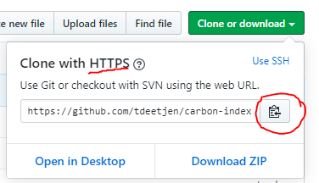
         4. then paste that url back into the command prompt and hit Enter
8. This will create a new folder that copies everything from your github carbon-index repository down to your local computer.

**Run the Python Program**

1. Install Python 3 using [Anaconda](https://www.anaconda.com/distribution/)
2. [Create the Conda environment](https://conda.io/projects/conda/en/latest/user-guide/tasks/manage-environments.html#creating-an-environment-from-an-environment-yml-file)
   1. open the Anaconda Prompt
   2. use “cd” to change directory to the cloned repository folder (where the environment.yml file is located)
   3. enter the command: conda env create -f environment.yml
   4. verify that the new environment was installed
      1. enter the command: conda env list
      2. you should see “psci” (i.e. power sector carbon index) as one of the environment options
3. Switch to the psci environment
   1. in the Anaconda Prompt, enter the command: activate psci
4. Update the params.py file
   1. Navigate to the “…carbon-index/src/” folder and edit the “params.py” file. Change the definitions of the following variables if needed:

DATA_DATE = Change every time. Change this to a string describing the date of the analysis. This string is only used to name files.

FINAL_DATA_YEAR = Change once a year. This is an integer of the analysis year.

LAST_ANNUAL_923_YEAR = Change once a year. To decide what value to put here, check:

* + 1. EIA 923: <https://www.eia.gov/electricity/data/eia923/> for the most recent full year of data
    2. EIA 860: <https://www.eia.gov/electricity/data/eia860/> for the most recent full year of data
    3. Take the lowest year of these two (e.g., in 2019 Q4, the EIA-923 had the full 2019 data, but the EIA-860 had the full year 2018 data. In that case, LAST_ANNUAL_923_YEAR = 2018)

FINAL_DATA_QUARTER = Change every time. This is the quarter that you are currently analyzing.

1. Run the program
   1. enter the command: python main.py
      1. This should initiate the main carbon index analysis program
      2. It will begin by downloading EIA and EPA data, which will be placed into the /data/rawdata and /data/transformed_data folders
      3. After all data is downloaded and cleaned, the program will begin calculating the results
2. Results will be put in folders:
   1. /data/results holds the raw form of the results. These file names are updated
      1. the filenames in this folder change with each new version, which automatically archives the results
   2. /web_files holds the results in a format intended for the website
      1. the blogtext file is also placed in the /web_files folder
      2. the filenames in this folder do not change from version to version
   3. /web_files_archive holds .zip copies of the web_files folder

**Check the Output Data**

1. In the /web_files folder:
   1. One by one, open up the 6 main csvs:
      * 1. annual_gen_website, quarterly_gen_website, monthly_gen_website
        2. annual_index_website, quarterly_ index _website, monthly_ index _website
      1. Compare the most recent few entries in these csvs with entries from 1-2 years ago to check that the numbers are in a typical range
         1. e.g., for 2019Q3, open the monthly_gen_website, check the values for July, August, September 2019, compare them against the values for July, August, September 2018 and 2017 as cross check.
   2. Open the blog.txt file
      1. Check all of the numbers in the blog file against the actual numbers in the csvs to ensure that they are consistent
   3. Open the two xlsx files
      1. Check the format and the different tabs
      2. Check the most recent numbers, make sure they look like they are in the typical range. These numbers should be the same as what is in the csv files. They are simply in a different format for website download.

**Update the Website**

1. Open a browser and navigate to emissionsindex.org/backstage
   1. Costa can set you up with a login
2. Create a new blog post
   1. Navigate to Entries>News & Events
   2. Click the “+ New entry” button
   3. Fill in the Title: Power Sector Carbon Index – 2019 Q2 Update
   4. Click the drop-down arrow on the “Save” button and select “Save as Draft”
   5. Fill in the rest of the information:
      1. Content: click the “+ Text” box, then copy and paste the entire text located in carbon-index\web_files\blog.txt
      2. Author: click the “+ Add User” box, then select your name. Repeat for Costa and other authors you’d like to include
      3. Brief: paste the first paragraph of the Content, from “The Carnegie Mellon Power Sector Carbon Index provides…” to “…down 9 percent from the same time frame in 2018.”
      4. Headline: Power Sector Carbon Index Q2 of 2019 Down 9% Compared to Q2 of 2018 (find the percentage in the last sentence of the text in the Brief)
      5. Banner Image: Under Banner Image, click “+Add an asset” and choose an image that aligns with one of the “Highlights” in the Content section.
      6. Show Banner Image on Details Page: toggle this button to Off
   6. Click the “Save draft” button
3. Update the homepage
   1. Navigate to Entries>Singles and click the link to “Homepage”
   2. Click the drop-down arrow on the “Save” button and select “Save as Draft”

**\*\*\*Make sure** whenever you edit the homepage that you are editing the “Draft #” version and not the “Current” version. The drop-down arrow next to the Homepage text will tell you which version you are editing. If you log-out and log-in, it will revert to the “Current” version, so always double-check.

* 1. Update the text under the Callout tab
     1. Callout Statistic:
        1. Line 1, “<span class=…>: change the number to match the number at the end of the blog’s first paragraph.
     2. Callout As Of: update year and quarter number appropriately
     3. Callout Percent Change:
        1. Update “Change Percent” to match the number at the end of the blog’s first paragraph.
        2. Update “Change Since” to one year previous, same quarter
        3. Update the next “Change Percent” to match the number at the beginning of the blog’s second paragraph.
  2. Update the Callout Image under the Callout Tab
     1. Create a new image:
        1. Open the “callout/carbon_index_carbon_image.svg” file (you can open a .svg file with Inkscape or other graphics program)
        2. Update the relevant text. There are 5 items to update:
           1. The large carbon index number, e.g. “935”
           2. The year and quarter beneath the carbon index number, e.g. “AS OF 2019 Q4”
           3. The first percentage number, e.g. “-7%”
           4. The year and quarter after the first percentage number, e.g. “since 2018 Quarter 4”
           5. The second percentage number, e.g. “-29%”
        3. Export the image as “Figures/callout_2019_Q4.png” using the correct year and quarter
     2. Back on the website, at Homepage>Callout tab>Callout Image:
        1. Click the small grey circle with the horizontal line at the bottom right of the current callout image (this will delete it)
        2. Click “Add Asset”
        3. Click “Upload Files”
        4. Navigate to the new callout image’s file location and upload it
        5. Then find that new image in the assets list, click it, and then click the “Select” button
  3. Update the text under the Features tab
     1. In the first box (where the headline is “The Power Sector Carbon Index”) change the url slug in the “Link” section to reflect the correct year and quarter. (This url will link to the blog post)
  4. Note:
     1. The “Charts” tab links to the javascript files in the Assets.
        1. Currently, since the Titles of the javascript files and the Titles of the associated csvs remain unchanged for each update, the Code in the “Charts” tab will continue to work without any updates
        2. The NERC map chart near the bottom of the page has been disabled. To enable it, select the gear in that particular “Chart/Single” box and click “Enable”
  5. Click the “Save as Draft” button

1. Upload the new data files
   1. ***Note that as you upload these new files, the website figures will change immediately. I.e., there is not a way to create a “draft” of this step. So before doing this step, make sure the blog post and homepage are complete and ready to be published.
   2. Navigate to Assets and click the drop-down arrow next to the “Javascript” folder
      1. At the Assets>Javascript>Data-Downloads folder
         1. Click the empty box next to the “Us Generation By Fuel Type” file
         2. Click the Gear icon drop down arrow (above the list of files)
         3. Click “Replace File”
         4. Navigate to the correct file in your computer and select “Open”
         5. You should keep the Title unchanged (see Notes below)
         6. Repeat the above tasks for the “Us Power Sector Co2 Emissions Intensity” file
         7. Notes:
            1. Each of the charts have a download button that points back to one of these two files.
            2. In the javascript file for each chart (see the directory carbon-index\web_files\JS_figures) there is a code line “window.location.href” that contains the url slug linking to these xlsx files int eh Assets folder
            3. If you change the way you name or store these files, you’ll also need to change this line in each of the javascript files and upload them all to the website backend to push those changes to the website.
      2. Select the Assets>Javascript>CO2-Chart folder
         1. Replace the csv files with the new versions created by the python files
            1. One at a time, for each of the three csv files:

***Note – make sure and check the file extensions of the files you are replacing. Many of the javascript and csv files have the same names. You want to make sure you are replacing csvs with csvs and not accidentally replacing the javascript files with csvs.

Click the empty box next to the file

Click the Gear icon

Click “Replace File”

Navigate to the correct csv file (in the directory “carbon-index\web_files”) and select “Open”

The Titles for these files should remain unchanged

* + 1. Using the same method as above, replace other csv files
       1. In Assets>Javascript>Fuel-Chart, replace 3 csvs
       2. In Assets>Javascript>Index-Chart, replace 3 csvs (these are the same csvs as used in the “CO2-Chart” folder)
       3. In Assets>Javascript>State-Map, replace 2 csvs
  1. Note: each of these folders also contains javascript files that read the csvs and create the website’s visualizations. If you need to update these files, you can replace them using the same method as described for the csv files. Note:
     1. The Titles of the javascript files should remain unchanged
     2. It may take a few hours or days for the website to refresh and show the new visuals.

1. Publish
   1. Navigate to the blog draft and select Live Preview to check the content.
   2. Navigate to the homepage draft and select Live Preview to check the content
   3. If everything looks good:
      1. Publish the blog
         1. Navigate to the draft blog post under Entries>News & Events.
            1. It will be located near the bottom of the list of blog entries
         2. Click the drop-down arrow on the “Save draft” button and select “Publish Draft”
      2. Publish the homepage
         1. Navigate to the draft homepage under Entries>Singles
         2. Under the drop down box next to homepage (it should say “Current”) select the draft version you are working on
         3. Click the drop-down arrow on the “Save draft” button and select “Publish Draft”
2. Verify
   1. Using incognito mode—or whatever method you want to use to bypass or delete your current browser cookies—go to emissionsindex.org and make sure everything looks as planned
      1. Cookies may interfere with the figures being refreshed

**Archive**

Archive the updated web_files documents by using git to push those files back up to github.

* + - 1. Open up command prompt and navigate to the carbon-index folder
      2. Enter the command “git status” to see which files have been changed
         1. The output should show that all of the csv and xlsx files in the web_files folder have been changed.
         2. The output should show a new *.zip file in the web_files_archive folder

1. git add -A
2. git commit -m “message”
3. git push
4. Go to your github account and look at the carbon-index repository
   1. You should see some new versions of the csvs, xlxs, and blog.txt files in the web_files folder as well as a new archived *.zip folder in the web_files_archive folder
   2. You can tell that these are new because the description right by the file name will have the message you included in your commit.
5. Send your new updates to the files on to Costa (the EmissionsIndex github user) for approval.
   1. Click the Pull requests tab and select “New Pull Request”

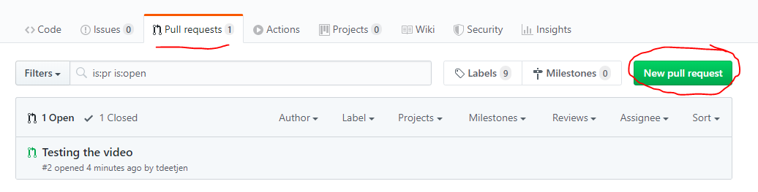

* 1. Click “create pull request”

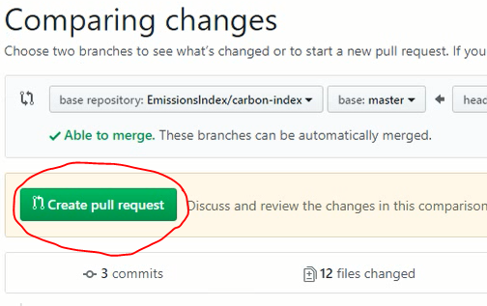

* 1. Add a Title. Be descriptive.
  2. Leave a comment. Be specific. Tell Costa why you’re requesting the pull. Usually you can just comment something like, “These are the new web_files and web_files_archive data after running the 2019 Q4 update” or something like that.
  3. Then, at the bottom right of that box, click “Create pull request”

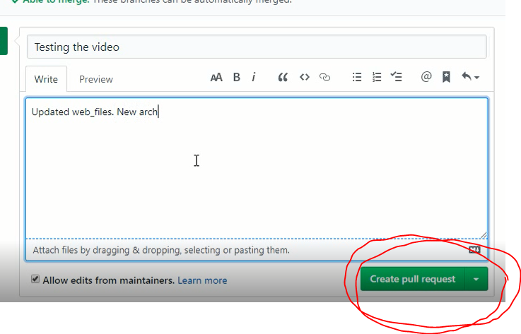

**Bonus: Editing Code**

If you need to edit the python, javascript, csv or other files, you can use the same above protocol to push those changes back to github.

1. Make the necessary changes to the local files on your personal computer.
2. Then repeat Archive steps 1-7 above. When you run “git status” you should see that the files you’ve edited are being tracked by git and are ready to add, commit, push, and then pull request.

**Help Understanding the Code**

There a number of python scripts and background data files that this code uses. The complexity, connections between files, importing/exporting of functions between files, etc. can make the program a bit difficult to understand.

Start with the “carbon-index/code flowchart.txt” file. It contains a basic rundown of the different folders, the scripts in those folders, and how they relate to the other scripts in the program.

Otherwise, I’ve tried to leave enough comments at the beginning of each function to explain the functions’ basic goals, purposes, and operations.

**Marketing**

Costa – not sure if you want to add something here for twitter, email newsletter, etc. or if you want to just handle that yourself?